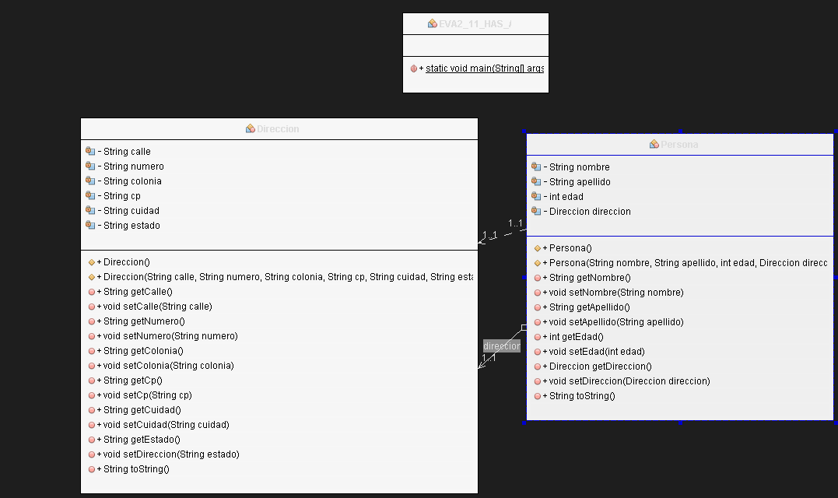EVA2_11_HAS_ A